Test Strategy
I plan one ensuring that every part of my program works and make sure that the inputs are all sanitised so that it does not crash based on various input. I plan on testing code whenever it is written and whenever I implement code ensuring it functions with the rest of the system. My program shouldn’t crash under any circumstance but only inform the user of their errors then allow them to be fixed
Furthermore, I would like to ensure that my project have reached the goals I set out from the start so I will ask several students to set different sections of my program and then get a report back from them on how well that section worked and if it would be suitable for them as a student and any additional features that may need to be implemented.
In addition, I will request that a few students try to break my program, be it with invalid input or anything else with the intention to break the program. If successful in breaking the program this will show my where I must improve the code to make my program more robust and maintainable.
After all these tests, I will create a small survey where students will test the program as a whole and then rate each section of my program out of 10. This will give me a general overview of how successful each section of my program is.

Furthermore, I will create several tests which I plan to make sure that my program can pass. These will be unambiguous goals which I do not already know the outcome of and then I will test them or give them to other computer science students to test and then I will validate whether the test is a pass or fail. If it is a fail, then I will fix the problem as long as I have enough time.

Program Security

Security of Files
I will not be making any security measures for the text file as it does not contain any sensitive data such as a name or confidential data. The intended purpose for my program is to be educational and help student to learn to write using AQA instruction set and LMC. If a company were to use it, they may want security to keep their program code safe however this is not my intended purpose.

Testing

Functionality Of Program

It is essential that my program can be executed, function as intended, and provide the functionalities outlined in the objectives. In order to ensure that my program is rigorous, performing tests is crucial. The main goal is to ensure that my program does not crash due to invalid inputs and that all in instructions work as intended.

A level
This program's fundamental purpose is to help students answer A-level questions and improve their understanding of the AQA instruction set.
Here are a few examples A A-level questions. Ensure that my program is capable of helping students solve these is very important.
Question 1
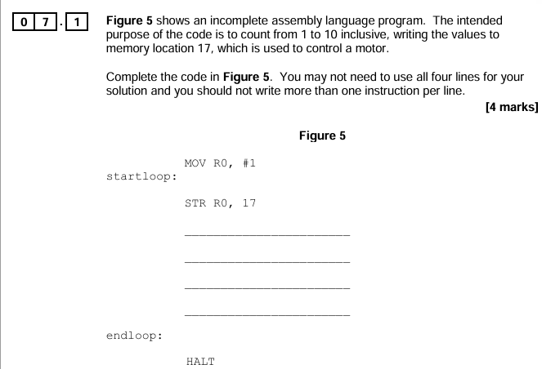

Completed code
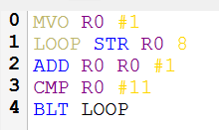
Registers
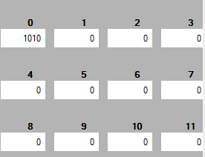
Memory
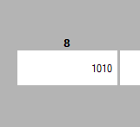
The program successfully iterates from 1-10 inclusive and then stores in a memory address. My program only allows you to write into a memory address up to 15, but for the purpose of this question it works.
Question 2
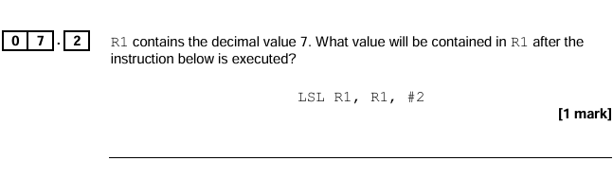
Completed Code
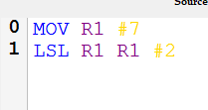
Registers
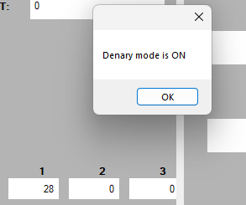

Memory
Test ID | Description | Test Data | Expected Outcome | Result
0.1 | Test the textbox in which users write code and determine whether the program will crash with any given input. |  | The program should not crash but give the appropriate error message.
0.2 | Test whether the program executes even if there is an error in the code |  | The program should not execute and then give an appropriate error message.
0.3 | All of the additional functions in the toolbox work as they are intended to. |  | All the functional should work as expected.
0.4 | The conversion between machine code and denary and vice versa work in all cases with no errors. |  | Machine code should be converted into their denary equivalent and vice versa.
0.5 | The error menu should contain all the error if any in the code and identify what type of error it is. |  | Whenever errors are checked, the error menu should contain all the errors in the code.
0.6 | All of the calculations and mathematical /bitwise operations result in the correct sum. |  | The result of the calculation must be outputted in the accumulator without error.
0.7 | All instructions should intend as functioned without any error or crash |  | All the instructions do what they are meant to do
0.8 | The addressing mode result in the correct registers/ memory being used |  | Memory addresses and registers and immediate addressing all work correctly.

Evaluation

